EquityBD, Date 20 August 2016.
Report on ADA workshop in Bangkok

1. Brief of the workshop

A three days workshop of ADA (Asian Development Alliance) held from 14-16th August 2016. The workshop is participated around 60 participants from Asia and the pacific countries. The workshop has focused on the issue of CSO (Civil Society Organizations) participation and engagement in monitoring of the UN Development Goal “SDG-16” (Sustainable Development Goal-16). Here, the report has mainly put the critical learning from the workshop on SDG 16 issues.

1. An overview on SDG-16 and its targeted issues

The world leaders have adopted a more comprehensive framework of development incorporating three strands of sustainability namely social, economic and environmental. This development agenda is known as Sustainable Development Goals (SDGs), which has replaced the MDGs at the end of 2015.

This new development framework on SDG has defined 17 goals for next 15 years. The goals will focus on some of the burning issues like total eradication of poverty in all form, sustainable management of natural resources along with the target of achieving peace in the world. SDG-16 is one of these goals, by which an achievement is being expected by the leaders to reduce violence and conflict among the states in the world.

The target of SDG-16 states to promote peaceful and inclusive societies for sustainable development, provide access to justice for all and build effective, accountable and inclusive institutions at all levels (Transforming our world: the 2030 Agenda for Sustainable Development, UN). This goal has designed the following ten numbers of targets for countries to be achieved by 2030;
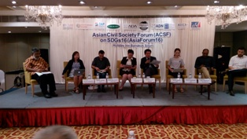
i. Significantly reduce all forms of violence and related death rates everywhere
ii. End abuse, exploitation, trafficking and all forms of violence against and torture of children
iii. Promote the rule of law at the national and international levels and ensure equal access to justice for all.
iv. By 2030, significantly reduce illicit financial and arms flows, strengthen the recovery and return of stolen assets and combat all forms of organized crime.
v. Substantially reduce corruption and bribery in all their forms.
vi. Develop effective, accountable and transparent institutions at all levels.
vii. Ensure responsive, inclusive, participatory and representative decision-making at all levels.
viii. Broaden and strengthen the participation of developing countries in the institutions of global governance.
ix. By 2030, provide legal identity for all, including birth registration.
x. Ensure public access to information and protect fundamental freedoms, in accordance with national legislation and international agreements.
xa. Strengthen relevant national institutions, including through international cooperation, for building capacity at all levels, in particular in developing countries, to prevent violence and combat terrorism and crime.
xb. Promote and enforce non-discriminatory laws and policies for sustainable development.

2. SDG-16 and context of Bangladesh

The conflict and violence in Bangladesh is multidimensional in it’s context. Bangladesh is the 8th largest populated country in the world and sharing the 2.19% of global population at present (World population database 20150). The majority of the populations are in fact living in poverty and their socio-economic condition is not in the standard. This phenomenon is a cause of creating socio-economic conflict among the individual, community and some time become large and overwhelming the discrimination with triggering conflict. Secondly; the lack of governance system is one of the causes to raise conflict that undermine the economic development and also weakening the government effort fighting poverty. So the present context of prevailing conflict and its trend in Bangladesh, it’s very imperative to work on the issue and achieve the target of SDG-16 for our government in case of achieving the other sustainable goals by 2030.

3. Government effort on SDG-16

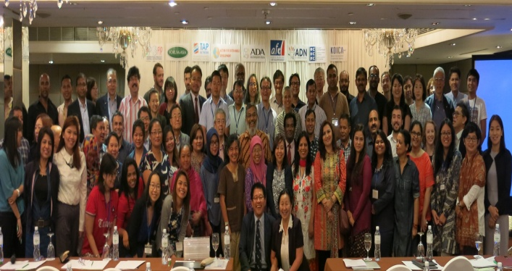
In fact there has no or less reflection of government effort in terms of reducing violence and conflict. Though government has been claim Bangladesh as a peaceful country, but the socio-economic and even governance scenario does not giving us a satisfactory hope for present and future. The SDG-16 prioritize three important issues are i. promote peaceful and inclusive development, ii. Ensure opportunities of equal justice for all and iii. Develop a transparent and accountable system in all spheres in the society and state. Achievement of these indicator is depend to enhance and strengthening governance in respective country. Bangladesh has been showing very less performance in all of these three indicators in last decades and stand a far behind position (ranked as 138 among 204 countries globally) among other countries in the world considering the governance performance.

4. CSO participation in global SDG process

The meeting said that the international CSOs have been engaging since the development of goals and participating to formulate necessary indicators and also its implementation, reporting and monitoring system. But concern is that the achievement of these goals in the developing and poor countries will be required a huge level of technical and financial cooperation. Developed countries have committed to provide their support to developing countries, but assumed very gray following their present role. Regarding the issue of supporting developing countries on SDG16, CSOs have participated in last UN-HLPF (High Level Political Forum) meeting and express their demand. The next HLPF will be held in 2019 where the agenda already set and will further discuss on the process and progress of SDG-16 among the countries. CSOs have scope to engage themselves with this process at local, national, regional and international level. CSO can work especially at their national level to planning process of government and its implementation and monitoring aspects.

4. Is CSO participation possible in government process in SDG implementation?

Civil Society Organizations (CSOs) make a difference in the different development sectors. They provide humanitarian relief and basic services, innovate in service delivery, build capacity and advocate with and for the poor. Recent years have also seen their role and sphere of influence in the development field. For example, CSOs in Ghana, Zimbabwe and Kenya now provide 40% of all healthcare and education services in those countries. There are an estimated 22,000 development NGOs in Bangladesh alone which provide some service (credit, health or education) to between 25-30% of the population. It is said that NGOs reach 20% of the world’s poor. Development NGOs have annual global revenues of some US$12 billion.

Nonetheless there are some obstacles are indentifies by the workshop in case of CSO engagement in the government policy processes. Interestingly, the common problems are assumed as insufficient capacity and knowledge of CSO. Lack of knowledge, some time the policymakers do not see CSO evidence as credible. Apart the funding is also a biggest constraint, because CSO could not do anything while needed due to lack of fund.

However, the engagement of CSO in the development process is very political in country context. If we look to the Philippine experience or example can see that, there has a strong political and constitutional system for CSO engagement in their development process. Bangladesh is very different and very weak in constitutional base for CSO engagement in development process. So we think that the political commitment is required at first step of government to engage the CSOs in the development process and mainstreaming despite having their glaring performance in socio-economic development.

Aminul Hoque

